Wendy Bronson
Assignment 4.2 MySQL Install
06/22/2026
CSD310-300H Database Development and Use (2265-DD)

MySQL Terminal Window
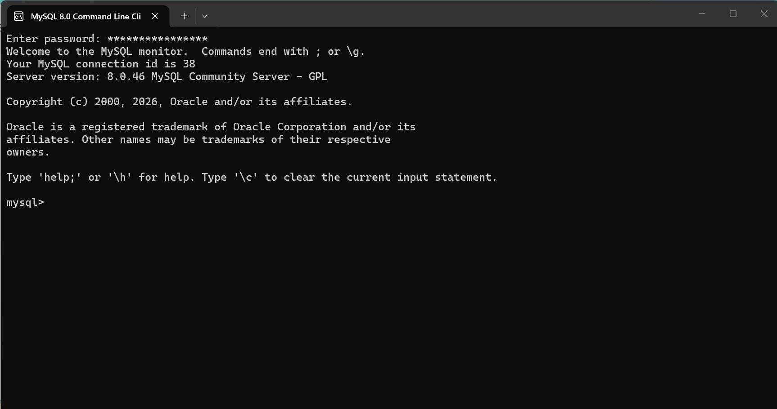
Movies Database Creation
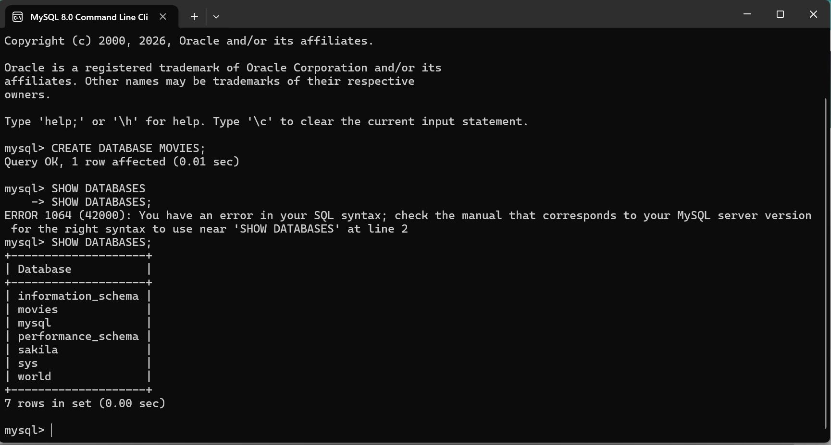

Functions for MySQL
- MySQL CHAR_Length() Function -The CHAR_Length() Function is used to return the length of a string (in characters). This function counts the number of characters, not the number of bytes, in a string. It is useful in scenarios where accurate character counts are needed. A good example of when this may be needed is when enforcing character-based limits, such as username or password limits.
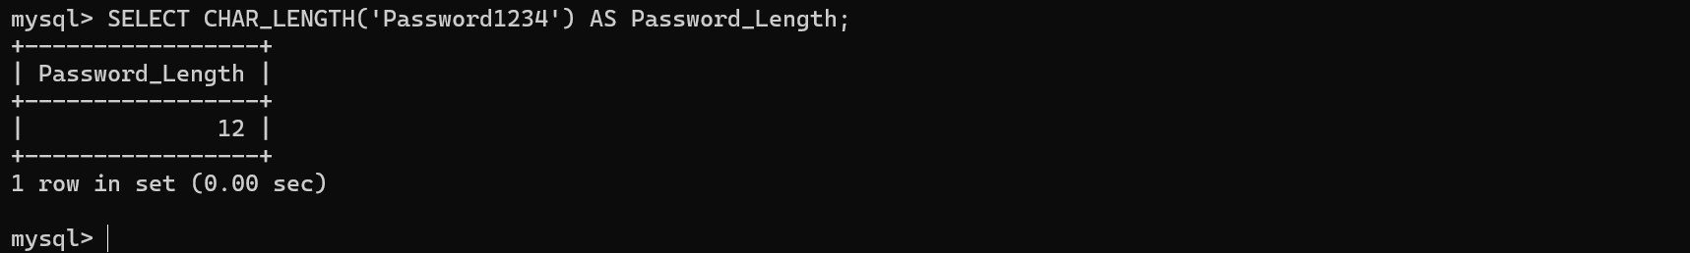

- UPPER() Function – The UPPER() Function converts text to uppercase. Is useful for creating standardized reports where names or codes need consistent formatting. A good example of when this may be needed is when creating a mailing list and names or state abbreviations need to be displayed in a consistent format.
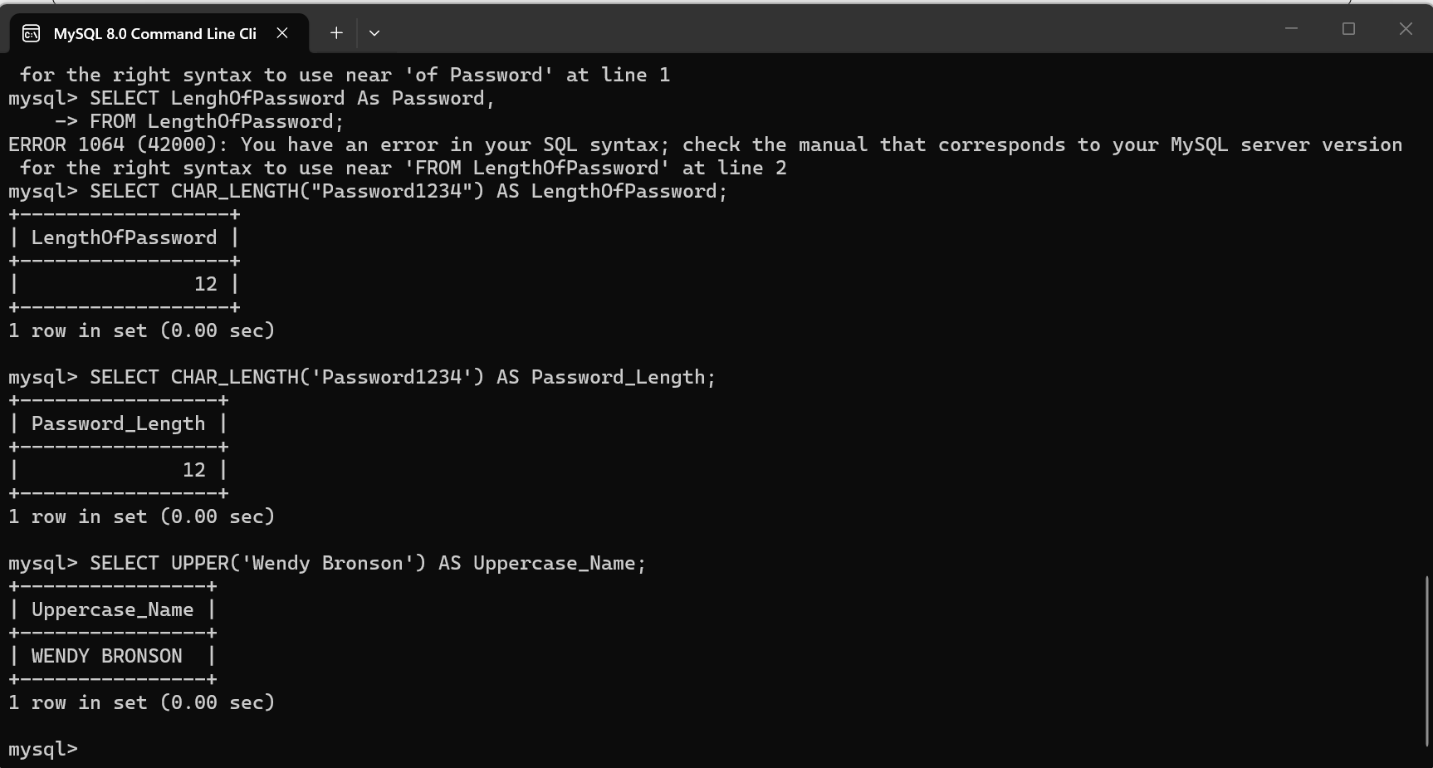

- REPLACE() Function: The REPLACE() function is used to find specific text in a string and replace it with different text. This can be helpful when a business needs to correct spelling mistakes, update outdated information, or make data more consistent throughout a database without having to manually change each record one at a time.